Assignment 3
Lab: C++ Parallel Programming

Akanksha Jadhao | PRN : 260740150004
Pratik Abhang | PRN: 260740150018

1) Write a C++ OpenMP program that creates an array of 1,000,000 integers, where:arr[i] = i
Calculate total with and without synchronization.

PROGRAM

#include <iostream>
#include <vector>
#include <numeric>
#include <chrono>
#include <omp.h>

int main() {
const size_t size = 1'000'000;
std::vector<long long> arr(size);

// Initialize arr[i] = i
for (size_t i = 0; i < size; ++i) {
arr[i] = i;
}

// 1. Without Synchronization (Data Race Expected)
long long total_without_sync = 0;
#pragma omp parallel for
for (size_t i = 0; i < size; ++i) {
total_without_sync += arr[i]; // Concurrent writes cause race condition
}

// 2. With Synchronization (Using reduction)
long long total_with_sync = 0;
#pragma omp parallel for reduction(+:total_with_sync)
for (size_t i = 0; i < size; ++i) {
total_with_sync += arr[i];
}

// Expected mathematical total: n * (n - 1) / 2
long long expected_total = (static_cast<long long>(size) * (size - 1)) / 2;

std::cout << "--- Problem 1: Array Sum ---\n";
std::cout << "Expected Total: " << expected_total << "\n";
std::cout << "Without Sync (Race Condition): " << total_without_sync << "\n";
std::cout << "With Sync (#pragma reduction): " << total_with_sync << "\n\n";

return 0;
}

OUTPUT
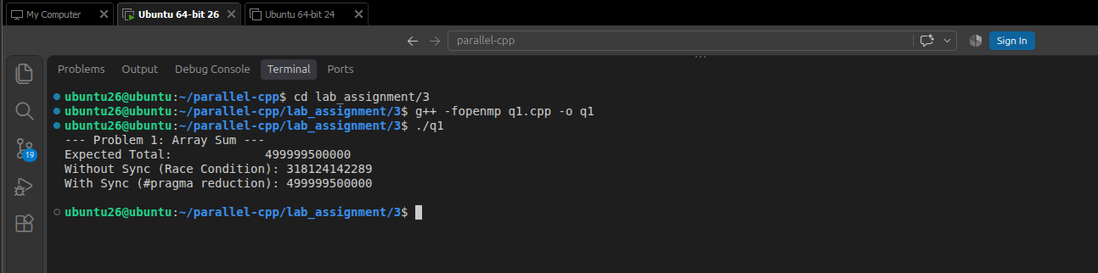

2) Write a C++ OpenMP program that creates an array of 2,000,000 integers containing
positive and negative values using arr[i] = (i % 100) - 50.
Count positive and negative numbers with and without synchronization.

PROGRAM

#include <iostream>
#include <vector>
#include <omp.h>

int main() {
const size_t size = 2'000'000;
std::vector<int> arr(size);

// Initialize arr[i] = (i % 100) - 50
for (size_t i = 0; i < size; ++i) {
arr[i] = (i % 100) - 50;
}

// 1. Without Synchronization (Data Race)
int pos_no_sync = 0, neg_no_sync = 0;
#pragma omp parallel for
for (size_t i = 0; i < size; ++i) {
if (arr[i] > 0) pos_no_sync++;
else if (arr[i] < 0) neg_no_sync++;
}

// 2. With Synchronization (Using reduction)
int pos_sync = 0, neg_sync = 0;
#pragma omp parallel for reduction(+:pos_sync, neg_sync)
for (size_t i = 0; i < size; ++i) {
if (arr[i] > 0) pos_sync++;
else if (arr[i] < 0) neg_sync++;
}

std::cout << "--- Problem 2: Count Positive & Negative ---\n";
std::cout << "Without Synchronization:\n";
std::cout << " Positive count: " << pos_no_sync << "\n";
std::cout << " Negative count: " << neg_no_sync << "\n";
std::cout << "With Synchronization (reduction):\n";
std::cout << " Positive count: " << pos_sync << "\n";
std::cout << " Negative count: " << neg_sync << "\n\n";

return 0;
}

OUTPUT
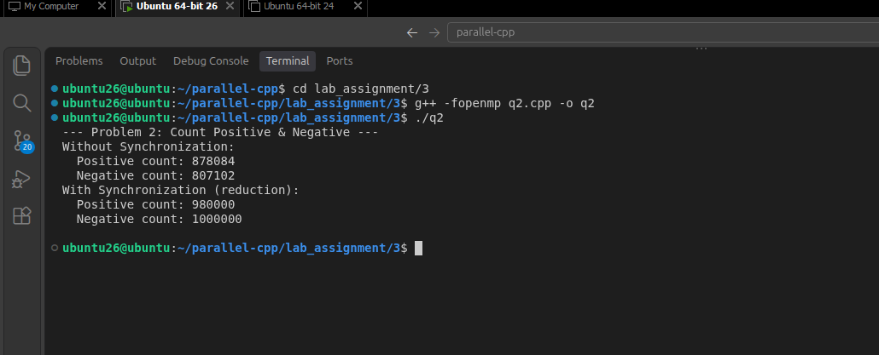

3) Create an integer array of 1,000,000 elements and initialize it with: arr[i] = i % 10000
Use OpenMP to find the maximum value in the array with and without synchronization.

PROGRAM

#include <iostream>
#include <vector>
#include <algorithm>
#include <omp.h>

int main() {
const size_t size = 1'000'000;
std::vector<int> arr(size);

// Initialize arr[i] = i % 10000
for (size_t i = 0; i < size; ++i) {
arr[i] = static_cast<int>(i % 10000);
}

// 1. Without Synchronization (Data Race)
int max_no_sync = -1;
#pragma omp parallel for
for (size_t i = 0; i < size; ++i) {
if (arr[i] > max_no_sync) {
max_no_sync = arr[i]; // Unsynchronized read & write
}
}

// 2. With Synchronization (Using OpenMP reduction max clause)
int max_sync = -1;
#pragma omp parallel for reduction(max:max_sync)
for (size_t i = 0; i < size; ++i) {
if (arr[i] > max_sync) {
max_sync = arr[i];
}
}

std::cout << "--- Problem 3: Maximum Value ---\n";
std::cout << "Max Without Sync (Unreliable): " << max_no_sync << "\n";
std::cout << "Max With Sync (reduction max): " << max_sync << "\n";

return 0;
}

OUTPUT
